|  |  |
| --- | --- |
| **Ex.No:8** | **Matrix Multiplication** |
|  |

***Aim:***

To develop a python program that multiplies two matrices.

***Main Algorithm:***

|  |  |
| --- | --- |
| **Step 1:** | Start Process |
| **Step 2:** | Initialize 3x3 matrix mat_a with some values |
| **Step 3:** | Initialize 3x3 matrix mat_b with some values |
| **Step 4:** | Initialize 3x3 matrix res_mat with zeros |
| **Step 5:** | Initialize i and j and k values with zeros |
| **Step 6:** | If k value is less than 3 then multiply positions of mat_a[i][k] and mat_b[k][j] and add with result[i][j] and store in result[i][j] |
| **Step 7:** | Increment k |
| **Step 8:** | Else goto Step 9 |
| **Step 9** | Increment j |
| **Step 10:** | If j is less than 3 then goto Step 6 |
| **Step 11:** | Else goto Step 12 |
| **Step 12:** | Increment i |
| **Step 13:** | If i is less than 3 then goto Step 10 |
| **Step 14** | Else goto Step 15 |
| **Step 15** | Display res_mat |
| **Step 16:** | Stop Process |

**Flow Chart:**

**Pseudo Code Prime Finder:**

START

ASSIGN mat_a = [[2, 3, 4],

[4, 5, 6],

[2, 3, 7]]

ASSIGN mat_b = [[4, 5, 6],

[6, 7, 8],

[2, 3, 4]]

ASSIGN res_m = [[0, 0, 0],

[0, 0, 0],

[0, 0, 0]]

ASSIGN i = 0

ASSIGN j = 0

ASSIGN k = 0

WHILE i is less than 3 THEN

WHILE j is less than 3 THEN

WHILE k is less than 3 THEN

ASSIGN res_m[i][j] = res_m[i][j] + (mat_a[i][k] * mat_b[k][j])

INCREMENT k

END WHILE

INCREMENT j

END WHILE

INCREMENT i

END WHILE

PRINT res_mat

STOP

STOP

**Program:**

mat_a = [[2, 3, 4],

[4, 5, 6],

[2, 3, 7]]

mat_b = [[4, 5, 6],

[6, 7, 8],

[2, 3, 4]]

res_m = [[0, 0, 0],

[0, 0, 0],

[0, 0, 0]]

for i in range(3):

for j in range(3):

for k in range(3):

res_m[i][j] = res_m[i][j] + (mat_a[i][k] * mat_b[k][j])

for row in res_m:

print (row)

**Output:**

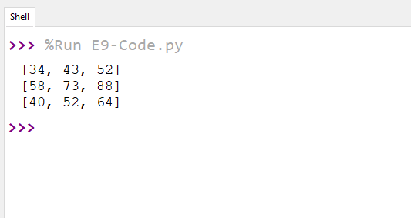

***Result:***

Thus the python program that multiplies two matrices was developed and tested successfully.